**NUTTY USER MANUAL**

**1. INTRODUCTION**

This manual includes instructions that explain the functionality of Nutty project; a food recipe community that offers users to share their recipes and give feedbacks on others. It also has recommendation algorithm that considers user preferences and similar user’s choices.

**2. LAUNCHING THE WEB APPLICATION**

To reach the website you can click the following link or type it to address bar of your browser:

<http://titan.cmpe.boun.edu.tr:8080/nutty/>

**3. SIGN UP**

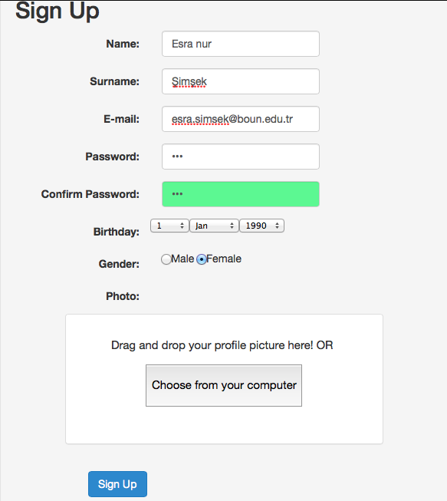

To use the system with full functionality you must register.

* Enter your name and surname.
* Write your e-mail address.
* Choose a password and write the same password to the field below to confirm it.
* Enter your birthday.
* Choose your gender.
* Upload your photo.
* Click sign up button. You can log in with your credentials after the page refreshes.

**4. LOGIN/LOGOUT**

**4.1 Login with e-mail**

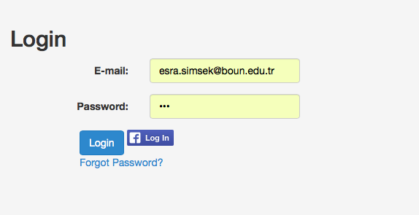

* Write your email and password that you registered with. Then click the “Login” button.
* You will see the successfully logged in message.

**4.1 Login with facebook**

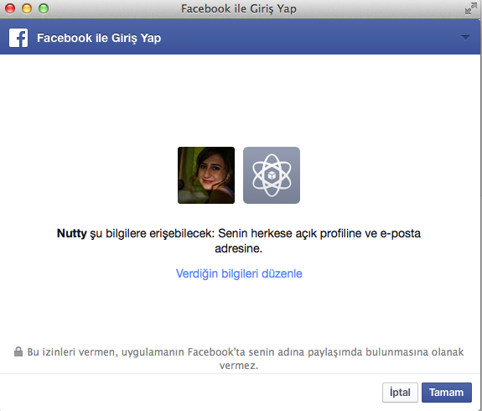

* You can login with your facebook account.
* Profile is created with facebook credentials.

**4.3 Forgot Password**

* If you forgot your password, just enter your registered e-mail adress. Password resetlink will be sent to your e-mail address by [noreply.app.nutty@gmail.com](mailto:noreply.app.nutty@gmail.com) account.

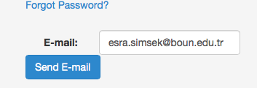

* A token is created for 1 hour for pasword reset. If you don’t change your password within 1 hour, token become invalid, and you need to go “Forgot Password” section again.

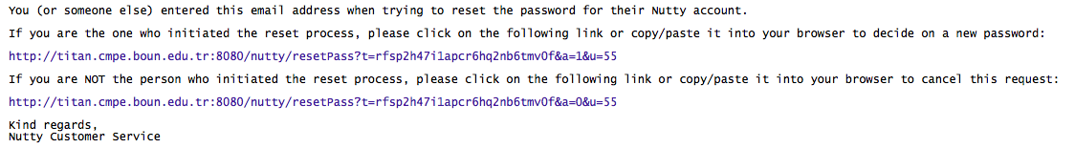

* Password reset screen.

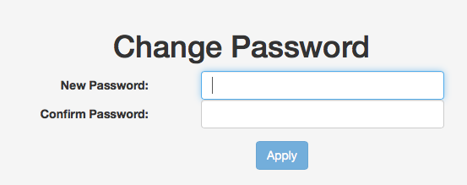

**4.4 Logout**

* You can logout by clicking the Logout button on the menu.

**5. BASIC SEARCH AND ADVANCED SEARCH**

**5.1 Basic Search**

* You can search for a recipe or a user on the search bar.
* Search function is available for guest users too.( only for recipe search)

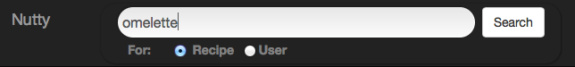

* Search results are listed on a pop-up page. ( Derived recipes are also listed.)

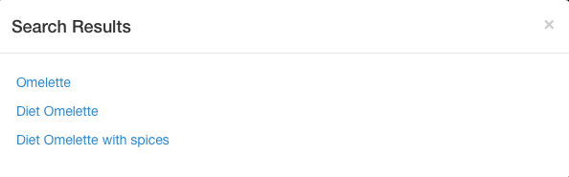

**5.2 Advanced Search**

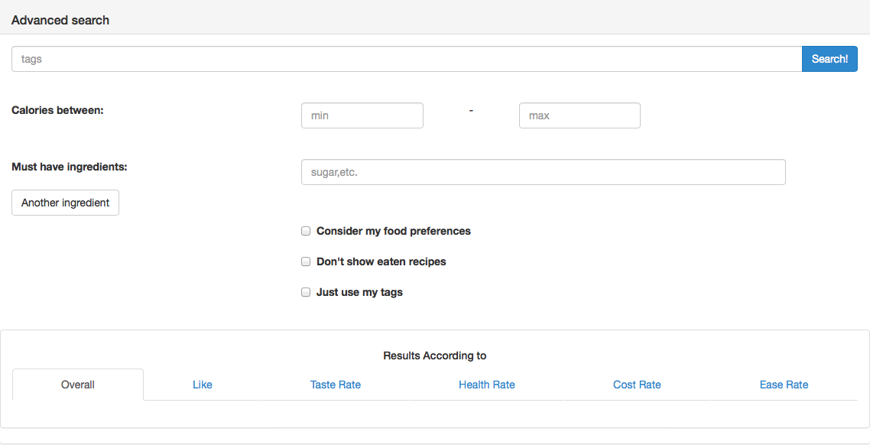

Advanced Search has an advanced recommendation algorithm that uses semantic tagging, consider your food preferences( intolerance, disease or simply non-preferred ingredients), ingredients and calorific values of the recipes.

Search results will be listed according to user preference (likes, health, cost, taste, ease or overall rates)

* Advanced Search function is available for registered users only.
* Semantic tagging is used in tag search. ( ie. if you search for “quick” tag, recipes with “fast” tag will be shown too. )
* You can search for a recipe :
* With tags ( semantic)
* With a calorie limit ( min-max)
* With must-have ingredients ( e.g recipes with beef and garlic)
* Advanced Search can consider your Food Preferences ( allergy or intolerance, entered in Options/Food Preferences) and hide the results with allergenic ingredients for you. ( Consider my food preferences)

( For example, you have lactose intolerance, and stated your allergy in the “Food Preferences” part, if you choose “Consider my food preferences” option, recipes with milk, butter or cheese etc. will not be listed. )

* You can hide the recipes that you have already eaten on the results. ( Don’t show eaten recipes)
* You can limit the results with the tags you entered. (i.e Don’t use semantic tagging). (Just use my tags option)
* Search results are listed according to user feedbacks ( likes, or taste, health, cost and ease rates, or average of them – overall ) .

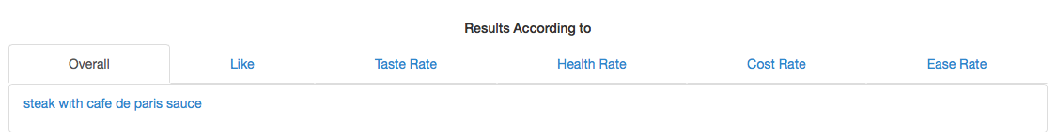

**6. ADD & DERIVE RECIPE**

**6.1 Add Recipe**

* Only registered users can add recipe.
* ‘Add Recipe’ function is reachable from navigation menu.
* A recipe includes
* Name of the recipe
* Its portion count
* The ingredients and their amonts ( in grams, spoon or cup etc.)
* Tags ( not mandatory)
* Upload the photo(s) of the recipe ( not mandatory)
* And Directions .

*Add Recipe Page*

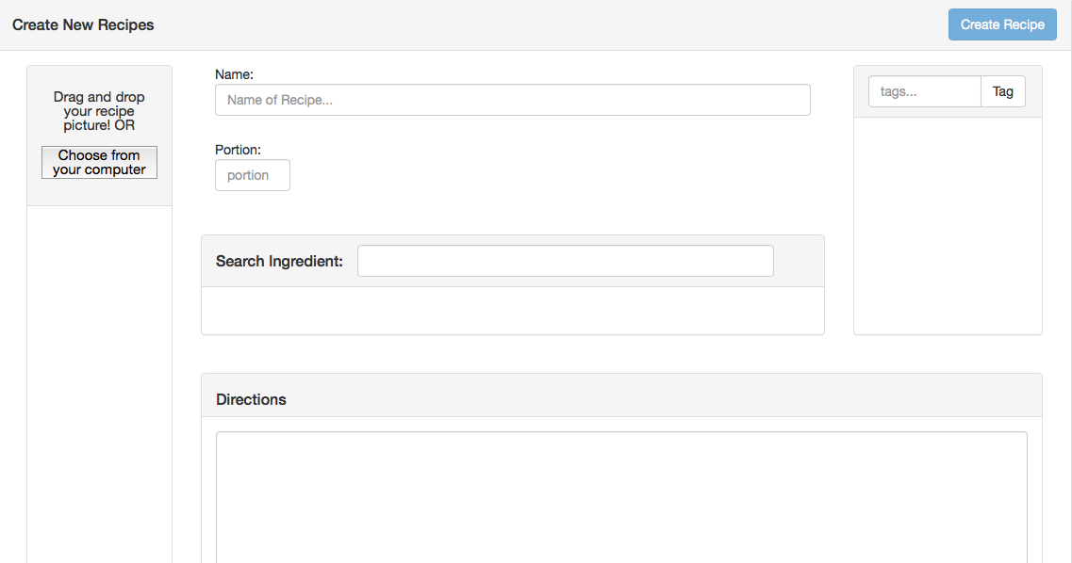

*Ingredients*

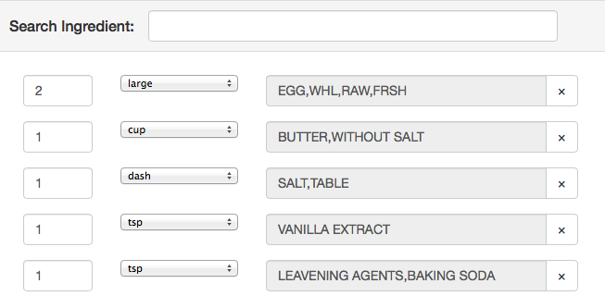

**6.2 Edit / Delete Recipe**

* You can edit or delete your recipes with “Edit” and “Delete” buttons on the recipe page.
* “Edit Recipe” page is similar to “Add Recipe” page, you can edit any part of your recipe.

**6.3 Derive Recipe**

* Derive recipe function is available for registered users.
* You can derive new recipes from original recipes or derived versions using “Derive New Recipe” button on the recipe page.
* On the recipe page, you can see its original version and also recipes derived from it.

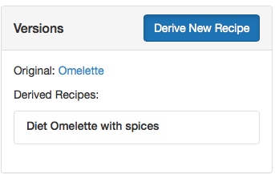

* Make changes on the original version and click on “Create New Version” button. New derived version will be created.

**7. SOCIAL FEATURES**

* Registered users can give feedbacks to other users’ recipes, ( eat, like, share, rate) and follow each other.

**7.1 Profile Page**

* Profile page is accesible from navigation menu.
* Every registered user has a profile page including:
* Name, surname
* Photo ( uploaded or from facebook login)
* Age, Gender
* Food Intolerances (like allergies)
* Health Conditions ( like diabet)
* Not Preferred ( unliked ingredients)
* Points and chef degree ( Gained from adding recipe etc.)
* Followings and followers’ counts
* User’s best recipes ( according to user ratings)
* Recent Activities (like newsfeed, activities, likes, shares etc.)
* Shared Recipes ( recipes that user “share”d)
* Recently Eaten Recipes ( recipes that marked as “eat”en by the user)
* To edit your profile information and your photo go “Profile Settings” using settings icon on navigation bar.

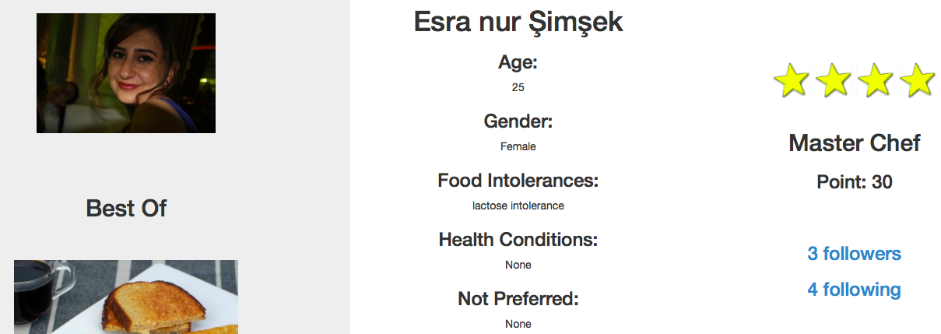

**7.2 Newsfeed in Profile Page**

* There is a newsfeed section on the profile page including 3 tabs:
* Recent Activity: Your followers, users that you follow, recipes that you and users that you follow liked, rated, ate and shared.
* Shared Recipe: Recipes that you shared.
* Recently Eaten: Recipes that you marked as eaten.

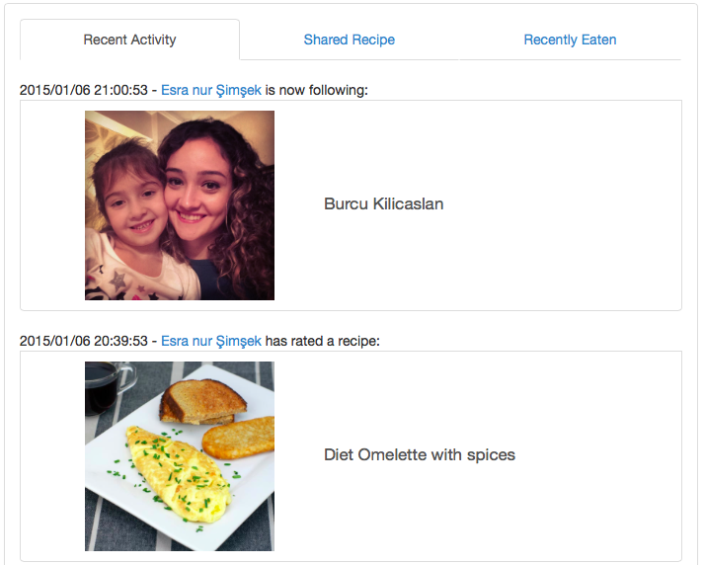

**7.3 Eat and Like Recipe**

* You can mark other users’ recipes as eaten using “Eat” button on the recipe page. This will show your rates’ quality and it is also used for hiding the eaten recipes on “Advanced Search” results.
* You can like other users’ recipes using “Like” button on the recipe page. This will affect recipe’s popularity and rank on “Advanced Search”.
* Your “Eat” and “Like” actions shown on your “Recent Activity” and “Recently Eaten” parts of your profile and also shown on your followers’ “Recent Activity” page.

*Recipe Page*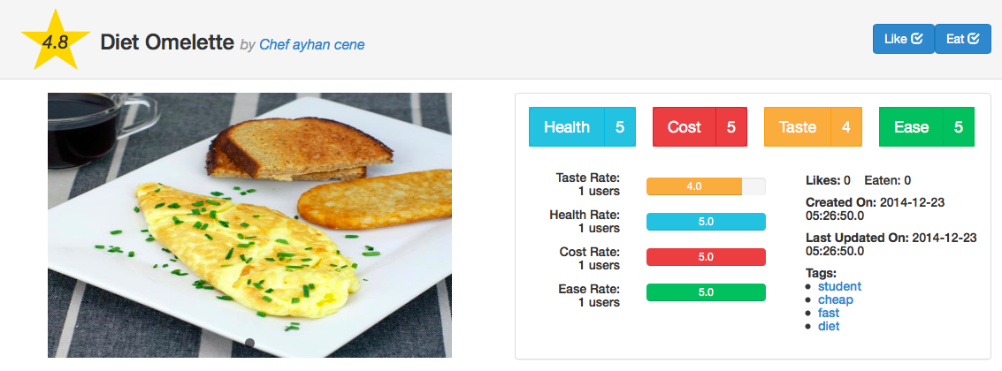

**7.4 Ratings**

* You can rate the recipes from 1 to 5 according to Health (1:Unhealthy-5:Healthy), Cost (1:Costy-5:Wallet Friendly), Taste (1:Tasteless-5:Yummy) and Ease ( 1: Difficult-5:Easy)
* Overall rating score of the recipe is avarage of all ratings.
* You can change your rating votes later if you want.

*Ratings Section*

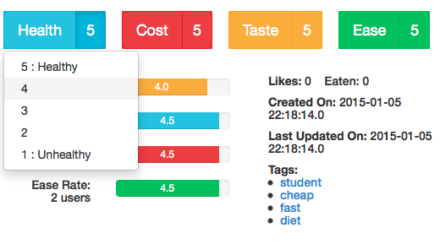

**7.5 Facebook Share**

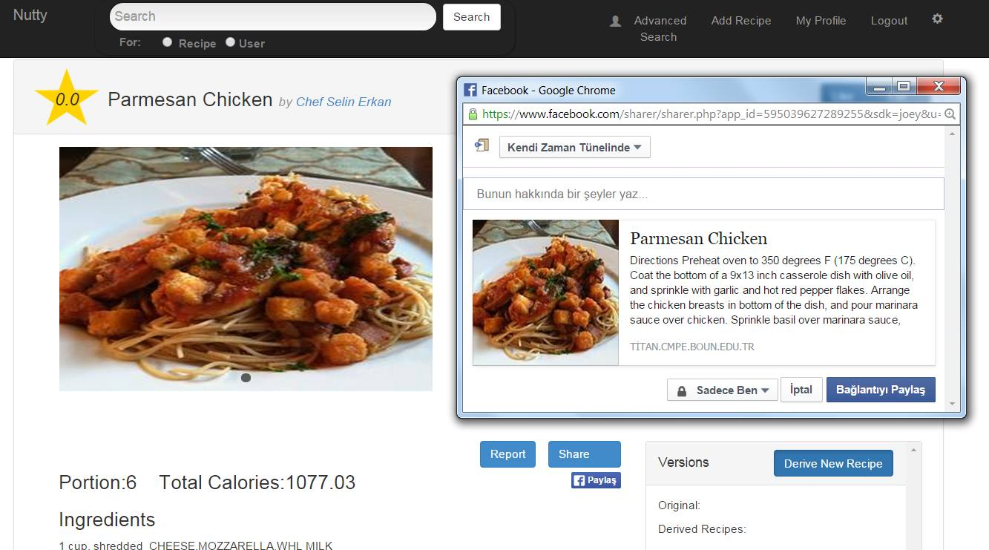

* You can share recipes on facebook. ( Doesn’t require facebook login)

**7.6 Share Recipe**

* You can share a recipe with “Share” button on the recipe page.
* Shared recipes will published on your followers’ “Recent Activity” page and on your profile.

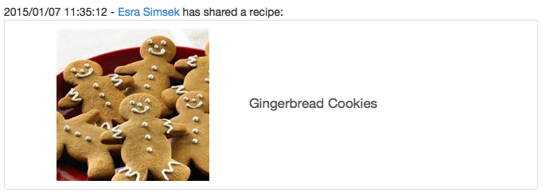

**7.7 Follow Users**

* You can “Follow” users using “Follow” button on their profile pages.
* A notification message is sent to users you want to follow and if they accept, their activities are shown on your “Recent Activity” section on profile page.
* When a user sent following request to you, icon on the navigation bar becomes red to notify you. (notification option on follow: Settings/Privacy Settings)





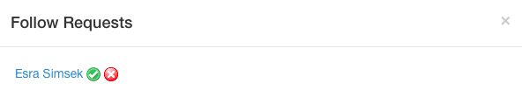

**8. SETTINGS**

* You can reach Setting Menu from the settings icon on the navigation bar.

**8.1 Profile Settings**

* You can edit your profile informatons on this screen.
* You can also delete your account using “Delete Account” button.

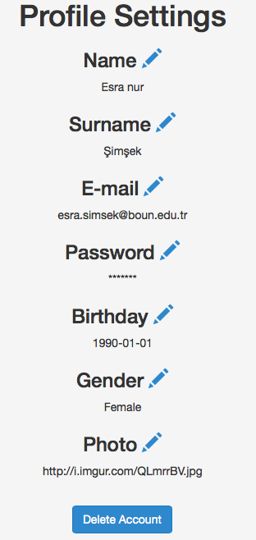

**8.2 Food Preferences**

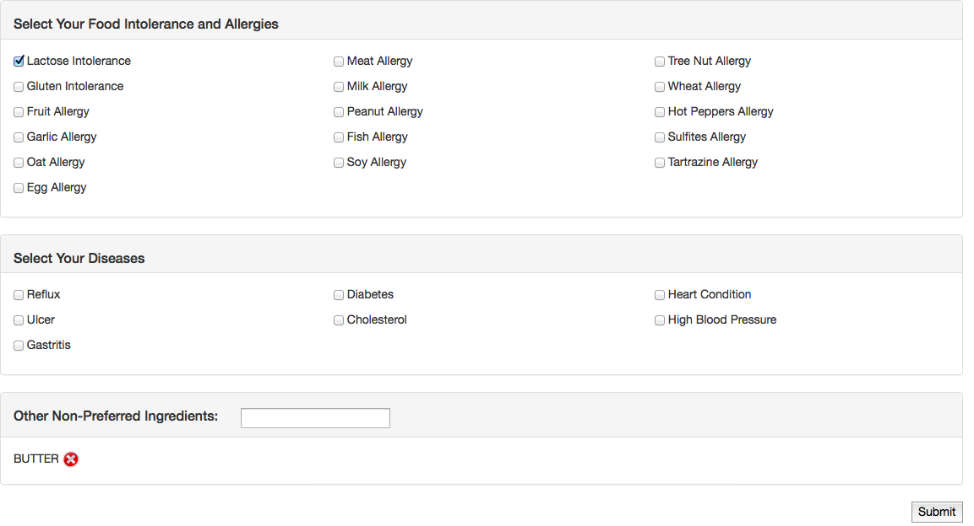

* You can state your food preferences from settings menu.
* Intolerance and Allergies:
* Diseases
* Non-preferred Ingredients
* State your allergy and intolerances, so that advanced search can eliminate the results with ingredients that you should not eat, and show more relevant and safer recipes for you.

( If you don’t like butter and don’t want to see recipes with butter, just add it to non-preferred ingredients and on Advanced Search check “Consider my food preferences” option. Recipes including butter will be hidden on search results.)

* You may choose to hide your Food Preferences from other users on Settings/Privacy Settings page.

**8.3 Privacy Settings**

* You can manage your privacy settings like:
* Being followable
* With request: In order someone to follow you, you should accept the follow request.
* Without request: Anyone can follow you without request.
* Health Conditions

Food Intolerances

Not Preferred Ingredients

Activities

* Hidden: Other users cannot see.
* Visible: Other users can see.

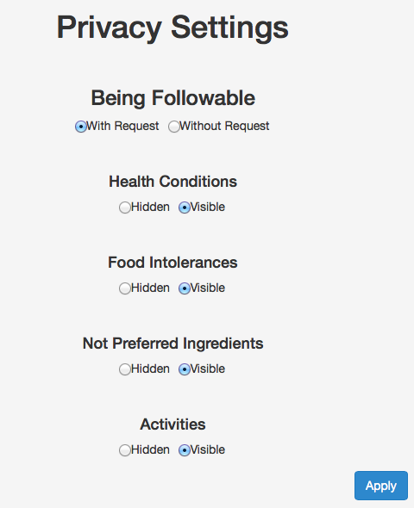

**9. RECOMMENDATIONS**

* You can see recommended recipes for you on the home(index) page.
* Recommendation algorithm works according to users with similar teste and results are shown as sorted according to relevance degrees.

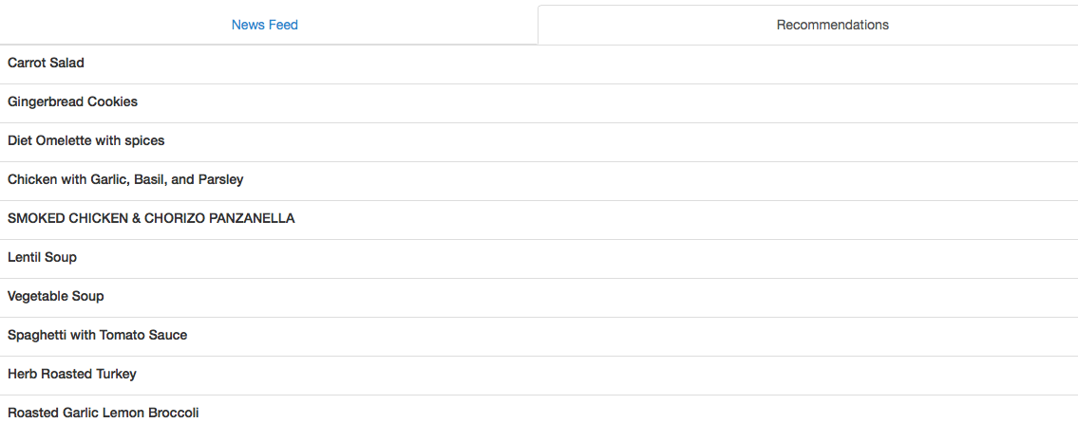

**10. GAMIFICATION**

* Users get points from their actions and gain chef degrees according to them.
* Here are the points for actions :
* Adding a recipe : 2 points
* Like : 2.5 points
* Eat : 2 points
* Rate : pointed for giving a rate 3 or more.
* Rate 3: 1.5 points
* Rate 4: 2 points
* Rate 5: 2.5 points
* Share : 2 points
* Comment : 1 points
* Here are the needed points for degrees :
* Beginner: 0 points
* Pre-chef: 1-4 points
* Chef: 5-19 points
* Master Chef: 20-49 points
* World Wide Chef: 50+